Endowed Chair Case Job Aid
Step 1:
To begin an Endowed Chair appointment or reappointment case for an existing faculty member click the “Start Endowed Chair Case” button located in the Cases in Progress tab.
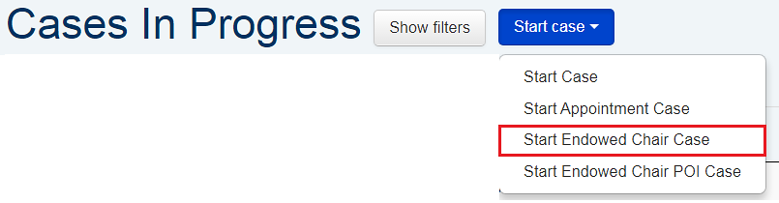

Step 2:
Select the faculty member from the list.
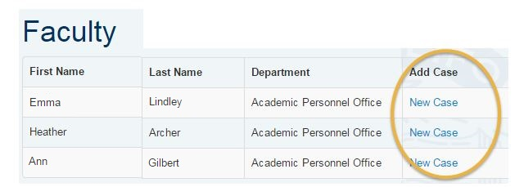

Step 3:
Using the calendar, select the effective date of the Endowed Chair appointment. Next, upload the CV. This is required to begin an Endowed Chair Appointment case. Once this is complete, press “Create endowed chair case.”
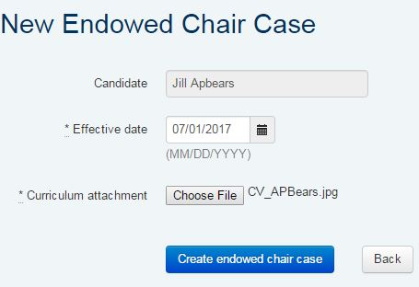

Step 4:
The case has been created. To change the effective date, upload or delete the CV, you will need to refresh the case. You may do so by clicking ‘Refresh Case’ under the Review Progress bar on the case header. 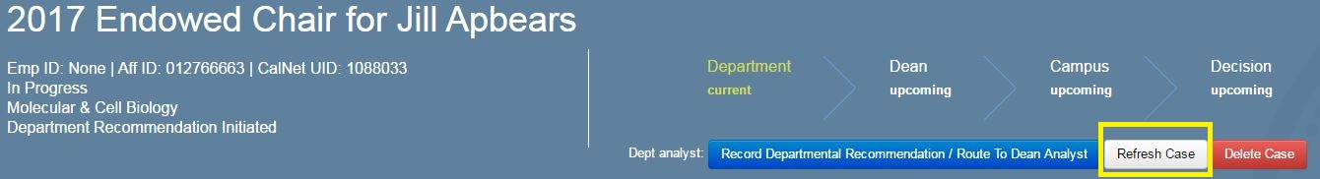

Step 5:
On the Overview tab, complete the following information:
Select “appointment” or “reappointment”
If case is a reappointment, enter in the Date of Initial Appointment to Chair. Leave this blank if it is an initial appointment.
Enter the full title of the endowed chair.
When this is complete, click “Save” at the bottom left corner.
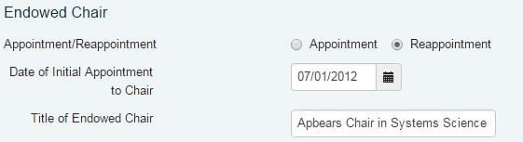

Step 6:
Begin the departmental appointment review process. For further detail on routing appointment cases refer to the following routing guide. Existing faculty will be able to view their Endowed Chair Re/Appointment cases in APBears. They will be able to view the Candidate Summary, Recommendation Overview, Departmental Review, and Routing Log tabs.

Step 7:
Complete and upload the Endowed Chairs checksheet as the Departmental Recommendation under the Documents tab. Update the “Salary Recommendation” tab by clicking the “Signoff” button. This indicates support for the re/appointment. Once complete, press “Record Departmental Recommendation/Route to Dean Analyst.”
Step 8:
Assign Dean as Dean Reviewer under “Reviewers” tab. Request review. Dean must then press “Signoff” button under Salary Recommendation tab to indicate concurrence. Once complete, Dean’s analyst presses “Record Dean Recommendation,” then “Route to Campus Review.”

