POI Endowed Chair Case Job Aid
Step 1:
To begin a new endowed chair case for a Person of Interest click the “Start Endowed Chair POI Case” button located in the Cases in Progress tab.
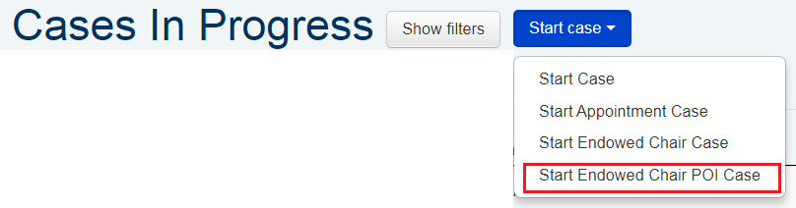

Step 2:
Enter the Person of Interest (POI) number from HCM in the Affiliate ID box and click “Search.” If the record is entered into HCM by 6pm, the record should be in APBears the following business day after 9am.
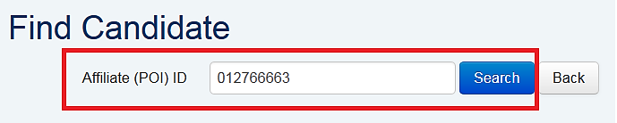

Step 3:
APBears will find the Affiliate ID (POI) if the record is current in HCM (start date < or = to today’s date and end date is = or > than today’s date). Verify the ID is correct and click ‘Pick Me’. Please note the effective dates in HCM must be current and not future dated.
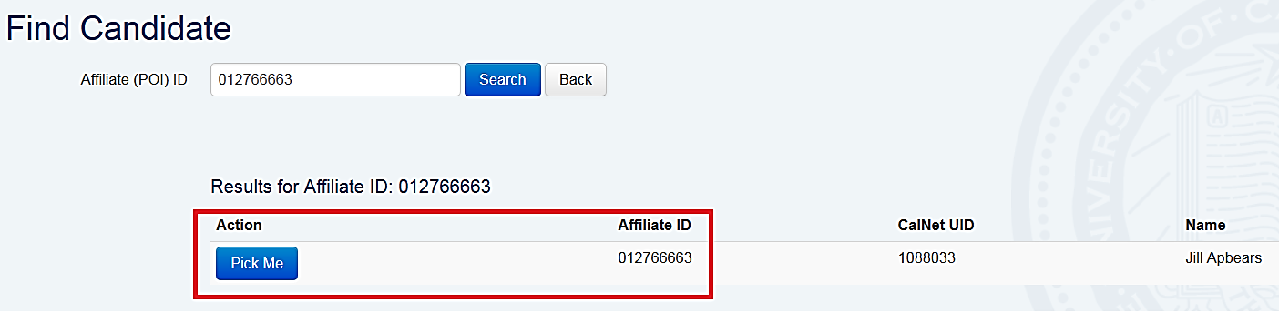

Step 4:
Using the calendar, select the effective date of the Endowed Chair appointment.
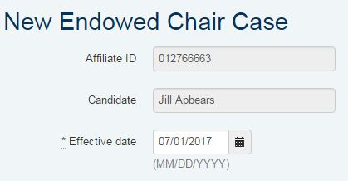

Step 5:
Select the org code for the department and enter the appointment percentage. Multiple departments may be entered. If the appointment is 0%, enter 0. Next, upload the CV. This is required to begin an Endowed Chair Appointment case. Once this is complete, press “Create endowed chair case.”
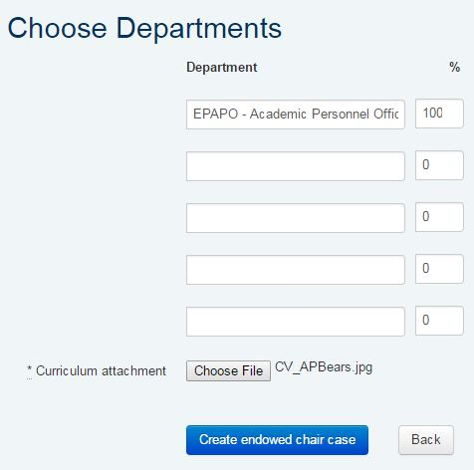

Step 6:
The case has been created. To change the effective date, upload or delete the CV, you will need to refresh the case. You may do so by clicking “Refresh Case” under the Review Progress bar on the case header.
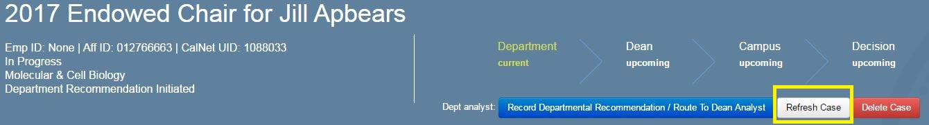

Step 7:
Begin the departmental appointment review process. For further detail on routing appointment cases refer to the following routing guide. Candidates will not be able to see their Endowed Chair POI case in APBears. They will not have access to APBears during the appointment process and they are not part of the review process for their appointment or Endowed Chair POI cases.
Step 8:
Complete and upload the Endowed Chairs checksheet as the Departmental Recommendation under the Documents tab. Update the “Salary Recommendation” tab by clicking the “Signoff” button. This indicates support for the re/appointment. Once complete, press “Record Departmental Recommendation/Route to Dean Analyst.”
Step 9:
Assign Dean as Dean Reviewer under “Reviewers” tab. Request review. Dean must then press “Signoff” button under Salary Recommendation tab to indicate concurrence. Once complete, Dean’s analyst presses “Record Dean Recommendation,” then “Route to Campus Review.”

