- To start an Excellence Review case, the designated Department Analyst can go to the “Cases” page in APBears. Then, click “Start case” followed by “Start Excellence Review Case” in the drop down menu.
- The Department Analyst will then be asked to search for the employee they wish to create an Excellence Review case for. After using the search box, click “New Case” to begin. (If someone does not show up after using the search box, please contact your designated AP analyst or the APBears help desk.)

- Enter the Effective Date, review Begin Date, and review End Date of the case. Click “Save.”
- Once the case has been created, the Department Analyst may begin working on the case. At this stage, the candidate should have uploaded any relevant materials into the Achievements section (which is now available for use for Lecturers). To upload those materials into the case’s Candidate Summary, the Department Analyst can click the “Refresh Case” button. (This button can also be used if the case’s effective date needs to be changed.)
- The Department Analyst can now add reviewers to the case. Go to the “Reviewers” tab, select the types of reviewers that need to be added, and then search for the persons to be added. When ready, the analyst can press the blue “Request Review” button to open up a case to the relevant reviewers.
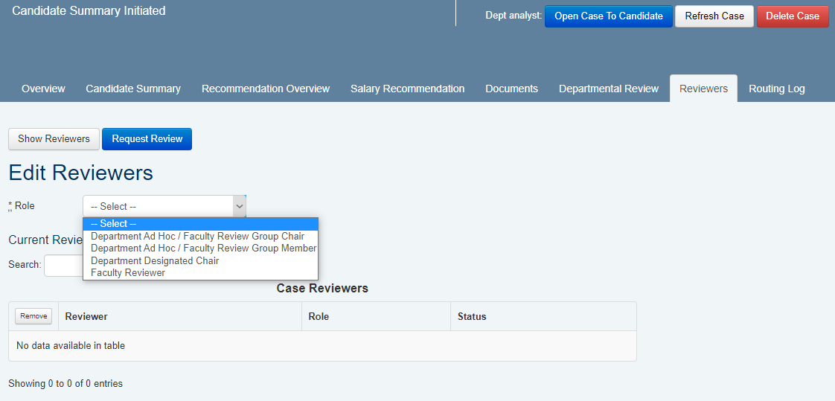
- Once the case has been prepared by the Department Analyst, they may click “Open Case to Candidate” to allow the candidate to review the case. Once the candidate has reviewed their case, they may sign off on the case which will allow the Department Analyst to continue work on the case.
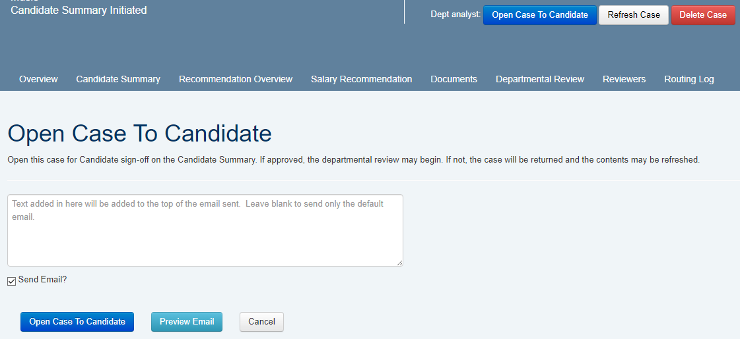
- The departmental review process can now begin. For further information on routing cases, you may follow the routing guide on our website: https://apapps.berkeley.edu/appointment-case-routing-guide. The routing for Excellence Review cases matches the routing process as appointment cases. The case goes under Departmental Review, Dean’s Office Review, and Campus Review before the case is closed and archived by the Department Analyst.
- Assign Dean(s) as a Dean Reviewer under the “Reviewers” tab. Request review when ready. When the case is at the Dean’s Office stage, the Dean must then press the “Signoff” button under the Salary Recommendation tab to indicate concurrence. Once that is finished, the Dean’s Analyst can click the “Record Dean Recommendation” followed by “Route to Campus Review.” For more information on how to assign reviewers, you may reference the “Assign Case Roles” help page on our website: https://apapps.berkeley.edu/assign-case-roles.

